Hope Presbyterian Church

**Sermon-Based Bible Study Group**

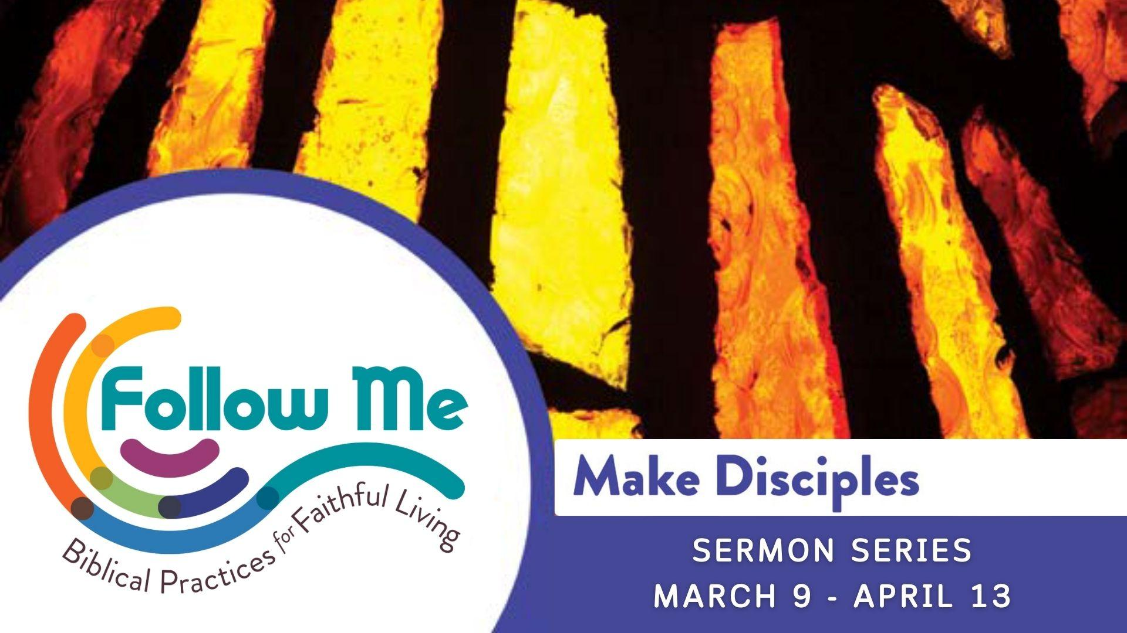

**March 16, 2025**

**Go! -** #2 in the series:*Make Disciples*

**Texts Referenced (NIV)**: Acts 1:6-8, Matthew 5:14-15, Matthew 28: 19-20

1. What stood out to you about the message?
2. Think about memorable trips or vacations where you traveled somewhere new.
   * What do you recall about the anticipation leading up to going?
   * How did it feel to be in a new or different place?
   * Why is going to new places easier for some than others?

**3. Read Acts 1: 6-8.**

When the disciples asked Jesus whether he would return the kingdom of God to Israel, his answer was not what they expected.

* + When have you been asked to go and do something you never expected?
  + What was your first response? What happened next?
  + What did you learn about yourself from this experience?

4.  **Reread Acts 1: 8.**

Think about where Jesus tells his disciples to go - “Jerusalem, and in all Judea and Samaria, and to the ends of the earth.”

* How does this verse help us think about our Jerusalem? Samaria? The ends of the earth?

**4. Read Matthew 28: 19-20.**

Consider how God’s call to “Go” may not always mean to literally “pack up and go” somewhere to share the Good News of Jesus.

* + How do we carry the gospel wherever we go in our everyday lives?
  + What are the challenges of this kind of discipleship?

**5.** Sadly, the spread of Christianity throughout history has resulted in tragic examples of “mission trauma.”

* + What are some examples of mission trauma?
  + What should our response be to these past and current practices as disciples?

6. How can we pray for you?