**Hope Presbyterian Church**

**Sermon-Based Bible Study Group**

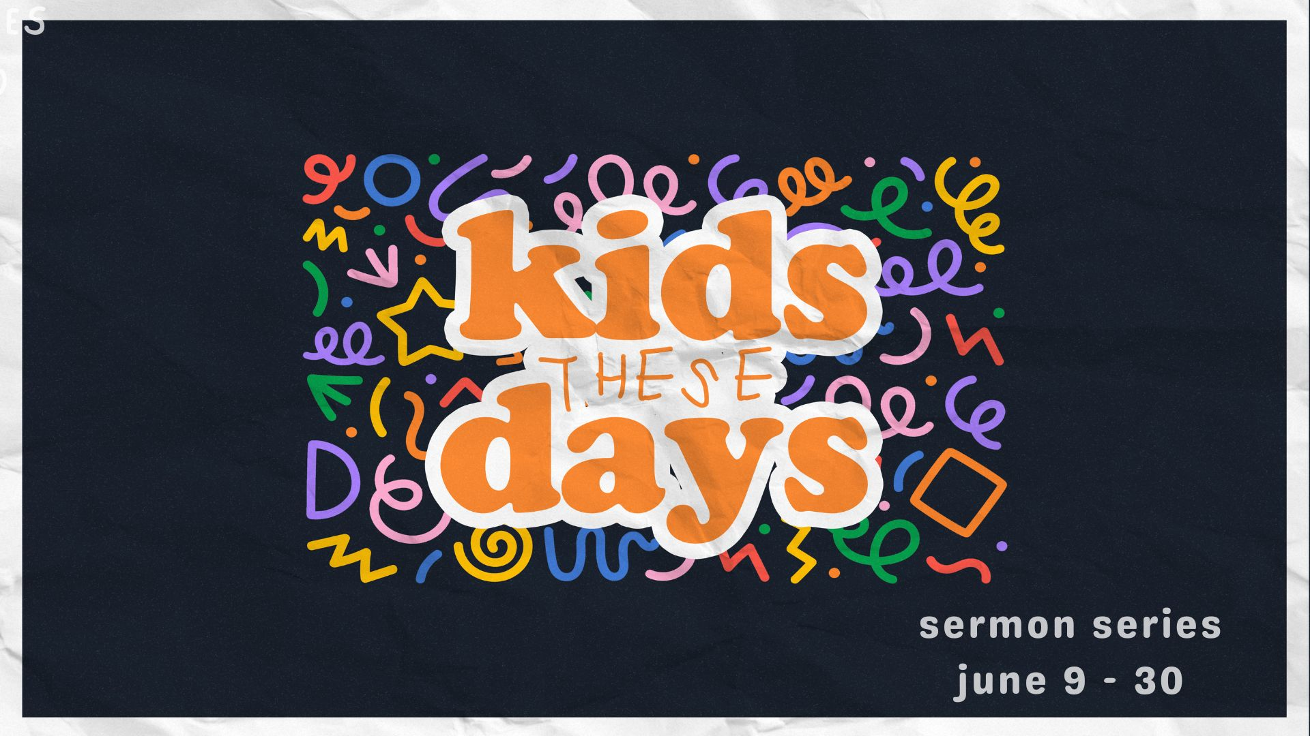

**June 30, 2024**

**“Connected Isolation”** - #4 in the series Kids These Days

**Texts Referenced (NIV)**: Ecclesiastes 4:9-12; 1 Corinthians 12:12, 21, 24-27

1. What stood out to you about the message?
2. Consider how significant historical or socioeconomic developments characterize the various generations ( e.g., Silent Generation - WW II; Baby Boomers - civil rights movement; Gen X - the birth of the internet; Millennials - the “latchkey” generation; Gen Z - first digital natives; Gen Alpha - born into a world fully encapsulated in technology).
   * How do these distinctions help explain what has long been described as “the generation gap”?
   * With which generation(s) do you most feel a “gap” of understanding or connection?

1. **Read Ecclesiastes 4:9-12.**
   * Which of the reasons for not being alone resonate most with you?
   * What challenges does this passage pose for individuals who are alone?
2. Much has been written about high levels of loneliness experienced by Gen Z.
   * What are your thoughts about Gen Z’s strong digital connectedness and their frequent experiences of loneliness, isolation, and depression?
   * How has loneliness also become a serious issue for older generations?
3. **Read 1 Corinthians 12:12, 21, 24-27.**
   * What about Paul’s metaphor of the physical body helps you understand how and why we need each other?
   * What might we say or do to show those younger and older that we appreciate them and want to connect?

6. How can we pray for you?